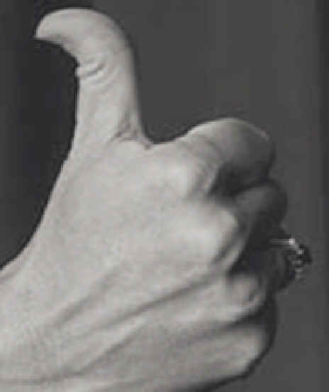
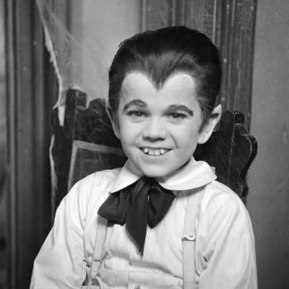

- Traits are individual qualities of a person.
- An individual has many traits and an individual's overall combination of traits is what makes them unique.
- Traits can be physical, behavioral, or medical.
- Traits can be influenced by genetics or environments.

Procedure:
- Fill out the Individual Traits Survey about yourself.
- When you have your survey filled out, compare your traits with your table partners.
- Next we will collect the data from the entire class and create a table to display the results.
- Finally, you will convert the findings to percentages and record your finding on the chart on the back of your survey.
- As a class, we will create a bar graph of our results and we will create pie charts of our traits to display.

Males | Females | Class Total

Trait | Type of Trait | YES | NO
Detached Earlobes
Tongue Rolls
Dimples
Right-Handed
Freckles
Curly Hair
Cleft Chin
Allergies
Hitchhiker's Thumb
Widow's Peak
Longer Ring Finger
Shorter Big Toe

 | Black | Blonde | Brown | Red
Hair Color

 | Blue | Brown | Blue-Green | Green | Hazel
Eye Color

Complete this survey to find out what observable traits you have!

- I am a Male Female
- I have detached earlobes Yes No
- I can roll my tongue Yes No
- I have dimples Yes No
- I am right-handed Yes No
- I have freckles Yes No
- I have naturally curly hair Yes No
- I have a cleft chin Yes No
- I have allergies Yes No
- I have a hitchhiker's thumb Yes No
- I have a Widow's Peak hairline Yes No
- My ring finger is longer Yes No
than my index finger
- My big toe is shorter Yes No
than my second toe
- My hair color is:
- My eye color is: ____________

Using the class data, calculate the percentage of students with each trait using the equation below.
) X 100 = _______ % YES
( $\frac{number of students with trait YES}{number of students in the class}$

If you know the % YES, you can find the % NO by subtracting.
*REMEMBER there should be a total of 100% for each trait!*
Trait | % YES | % NO
Detached Earlobes
Tongue Rolls
Dimples
Right-Handed
Freckles
Curly Hair
Cleft Chin
Allergies
Hitchhiker's Thumb
Widow's Peak
Longer Ring Finger
Shorter Big Toe

Now calculate the percentages of each hair and eye color.
 | % Black | % Blonde | % Brown | % Red
Hair Color

 | % Blue | % Brown | % Blue-Green | % Green | % Hazel
Eye Color

