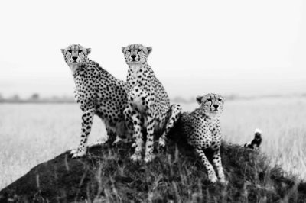

BACKGROUND: A wildlife reserve is a space designated for animals to live and reproduce in a safe environment away from human disturbances. Some reserves provide wildlife viewing areas and education centers for the public.
MATERIALS
- Construction Paper
- Pens & Pencils
- Colored Pencils & Markers
- Stencils & Rulers
- Craft Supplies
- Natural Materials
YOUR OBJECTIVE: In a small group you are to design a wildlife reserve for an endangered animal.

PROCEDURE
- Your reserve must encourage the animal's natural behaviors as well as provide for its physical requirements, such as feeding and breeding.
- In your group, choose and research your endangered animal and find out what types of behaviors and physical needs your reserve will have to cater to.
http://www.earthsendangered.com/list.asp
- Decide if your reserve will include a viewing and/or education center. Decide if you will have animal care facilities for sick or injured animals and housing for researchers, veterinarians, and specialists or if this will not be a part of your reserve.
- Once you have an idea of what to include in your reserve, create it!
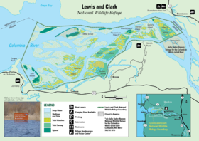
- Start by designing and drawing your reserve on paper. Make sure you label the individual areas. Examples: area for feeding, water source, breeding area, nesting and birthing area, shaded area, and play/exercise area. If you are including any of the human interaction components discussed above, make sure you include them in your design.
- Once you have a plan drawn, create a three-dimensional model of your reserve using the craft supplies and natural materials. Make the model as close to reality as possible.
- Once finished, prepare to present your reserve to the class and explain the components of your reserve, why it is unique, and how it will encourage breeding and growth of the endangered population.

